

ENM319 & BIM213 PROJECT FINAL REPORT

BIM213:

-Pınar SOYLUĞAN

-Oktay KAYA

ENM213:

-Burak KAMIŞOĞLU

-Ekin KAYDAL  
 -DenizMustafaBektaş

1.0 How to calculate MSE?

Below formula is our way to calculate MSE.  
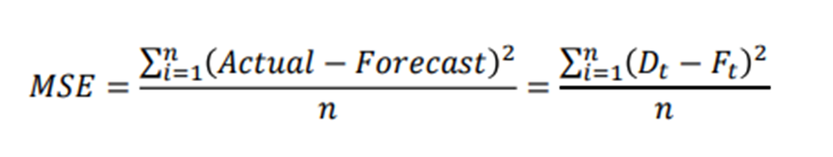  
   
  
  
 1.1

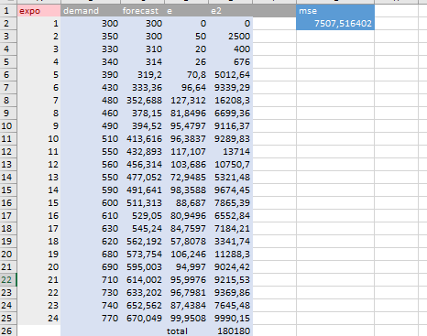

This table is composed of our Exponential smoothing (𝛼 = 0.2) calculations. By this calculations, we obtained a mse result which is 7507,516402. Below screenshot shows basic formula for Exponential smoothing.

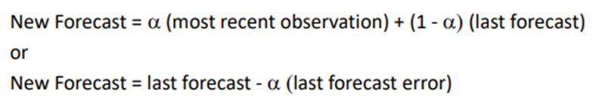

1.2

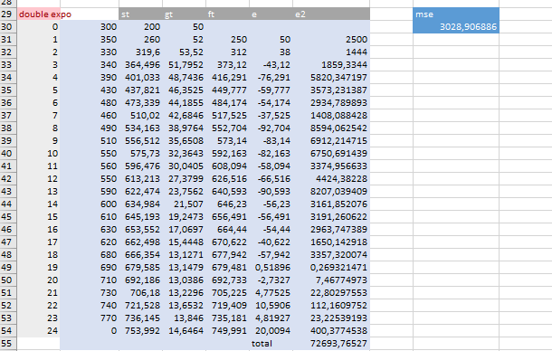  
  
This table is composed of our Double Exponential smoothing (𝛼 = 0.2) calculations. By this calculations, we obtained a mse result which is 3028,906886. Below screenshot shows basic formula for Exponential smoothing.

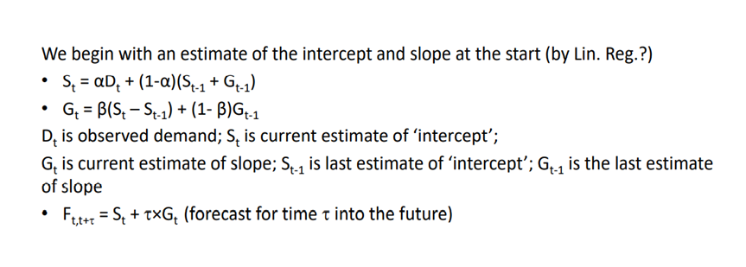

1.3

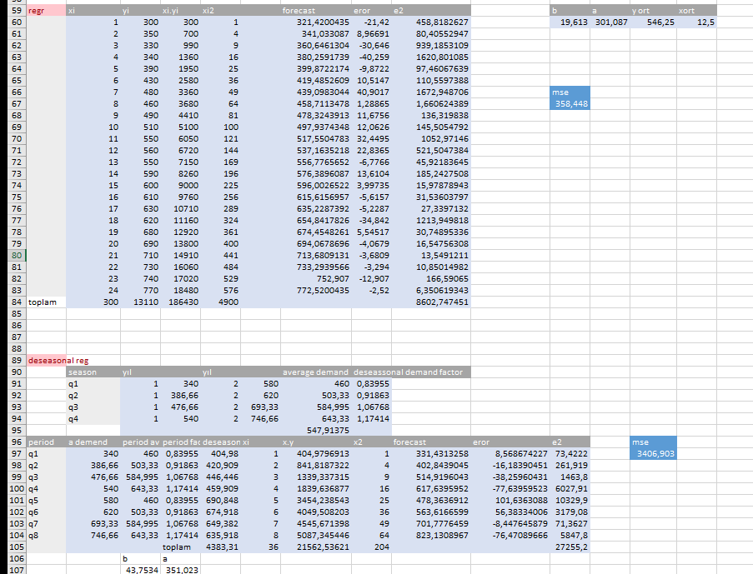

This table is composed of both Regression and Deseasonalized regression analysis (𝛼 = 0.2) calculations. By this calculations, we obtained 2 mse result which are 358,448(Regression) and 3406,903(Deseasonalized regression analysis) Below screenshot shows basic formula for Regression and Deseasonalized regression analysis.

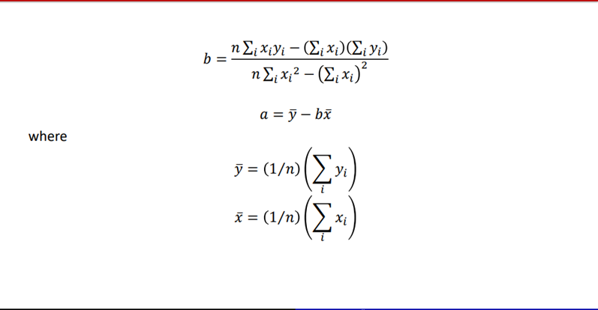

2.1  
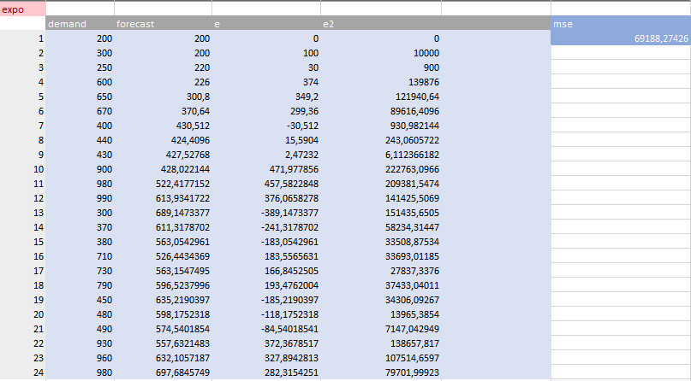  
  
  
This table is composed of our Exponential smoothing (𝛼 = 0.2) calculations for our Data Set 2 . By this calculations, we obtained a mse result which is 69188,27426.

2.2  
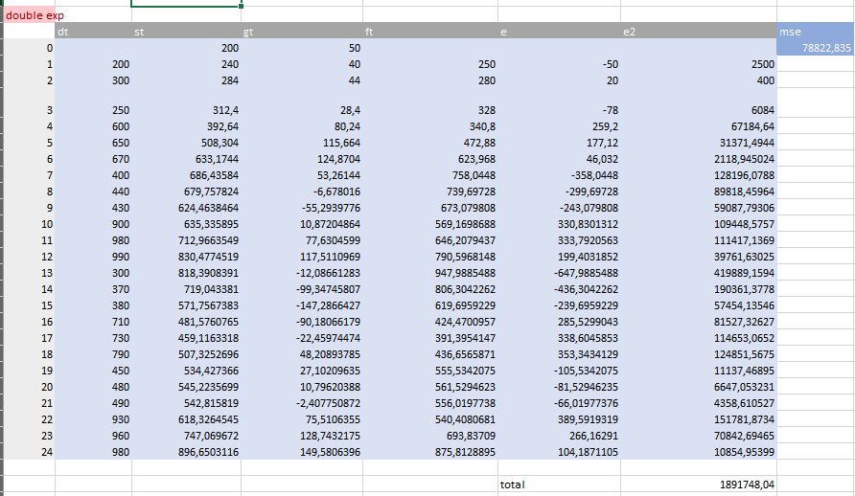  
  
This table is composed of our Double Exponential Smoothing calculations for our Data Set 2 . By this calculations, we obtained a mse result which is 78822,835.  
  
2.3  
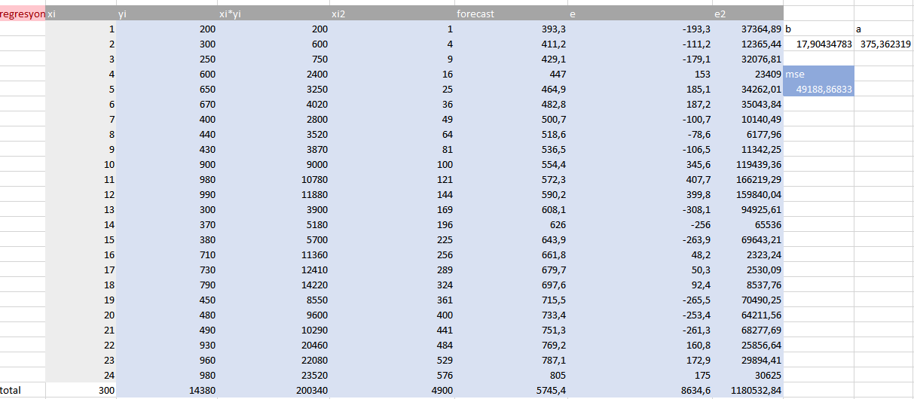  
  
This table is composed of our Regression Analysis calculations for our Data Set 2 . By this calculations, we obtained a mse result which is 49188,86833 .

2.4  
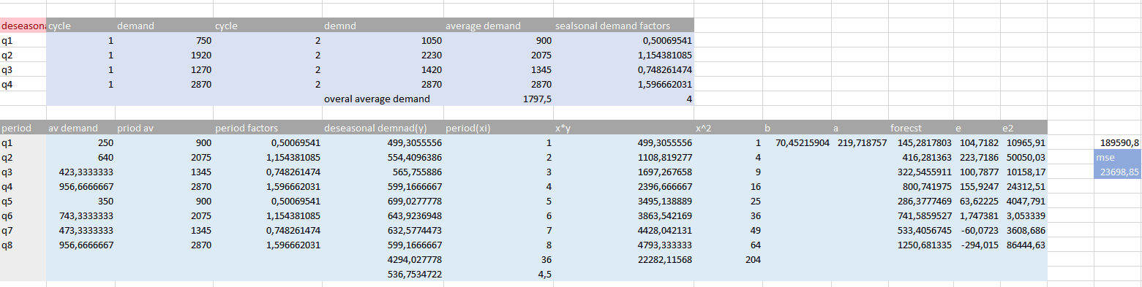  
  
This table is composed of our Deseasonalized regression analysis calculations for our Data Set 2 . By this calculations, we obtained a mse result which is 23698,85.

THE CODE PART:

1.1

Dataset.java

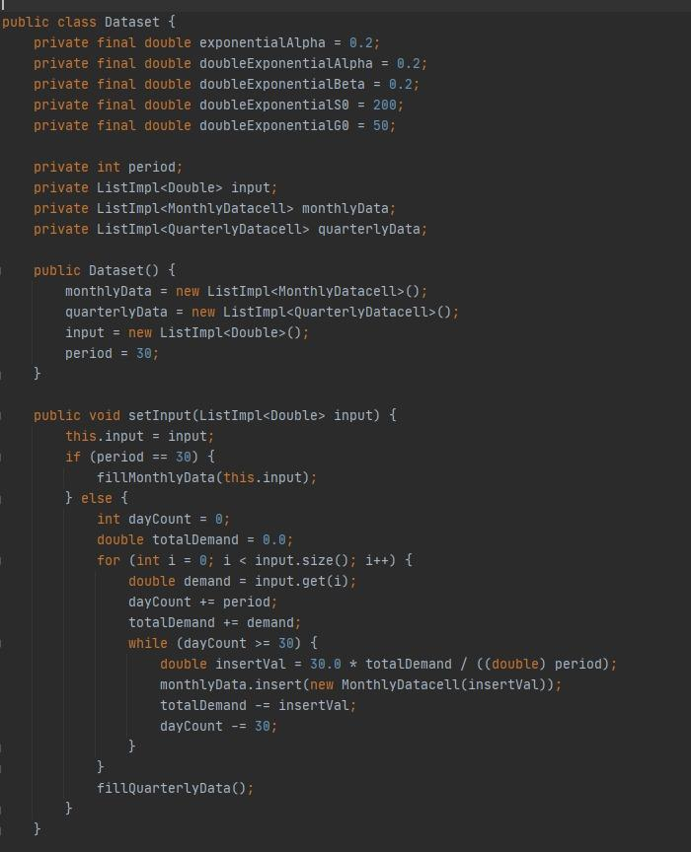

At first we defined the alpha and beta values that were given to us in our homework.

After the data arrives, it divides them into months at first and fills them out later.

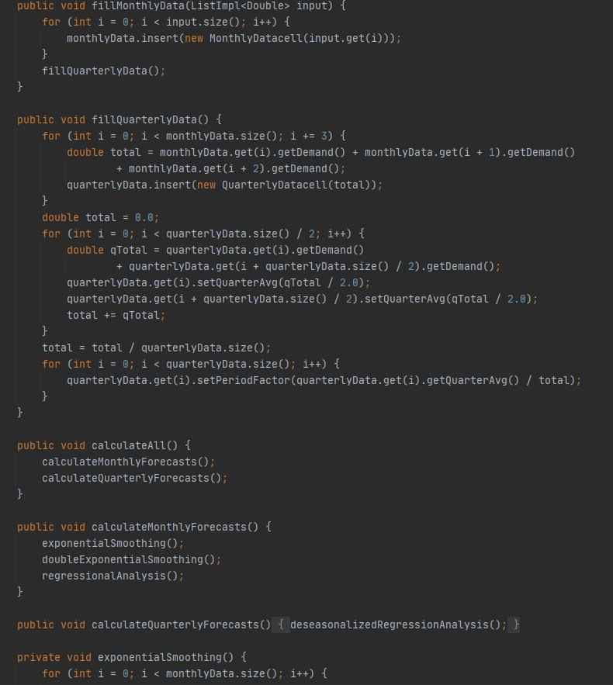

According to the months filled in, quarter calculations are started to be made one by one with the calculateAll method.As requested from us in the assignment, we needed to get monthly and annual forecast data, and we provided them with the calculation of data gaps using the calculateAll method.Then, the desired values and MSEs of the data were calculated by making calculations.

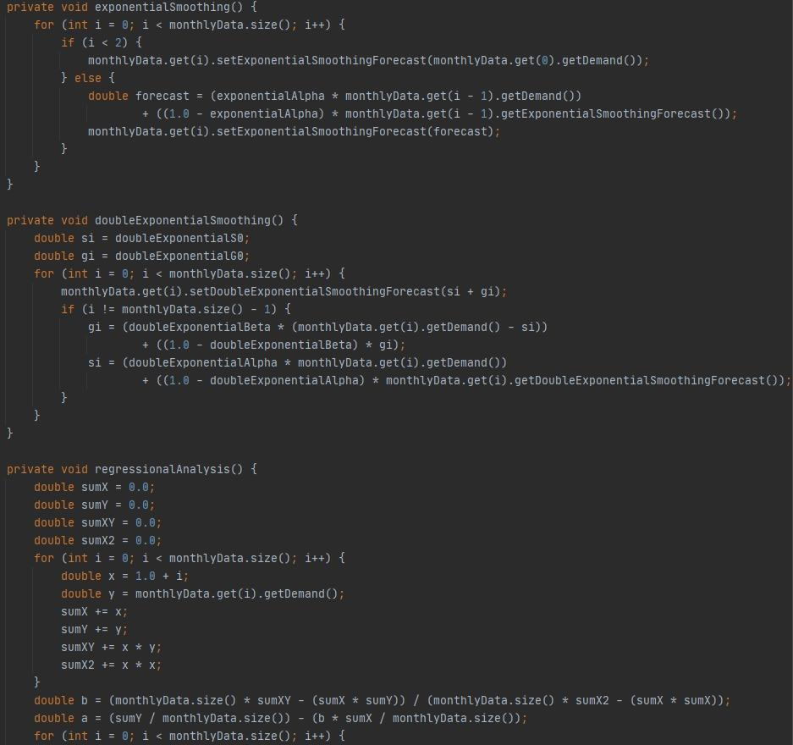

Thanks to the data and formulas we received from the industry department, we transferred them to our codes.We opened a method for each type of calculation, and then as the data in the dataset was entered, our calculations were made. The most important part here was to be able to transfer the formulas correctly. As you can see, we have also done these with the for and if else methods.

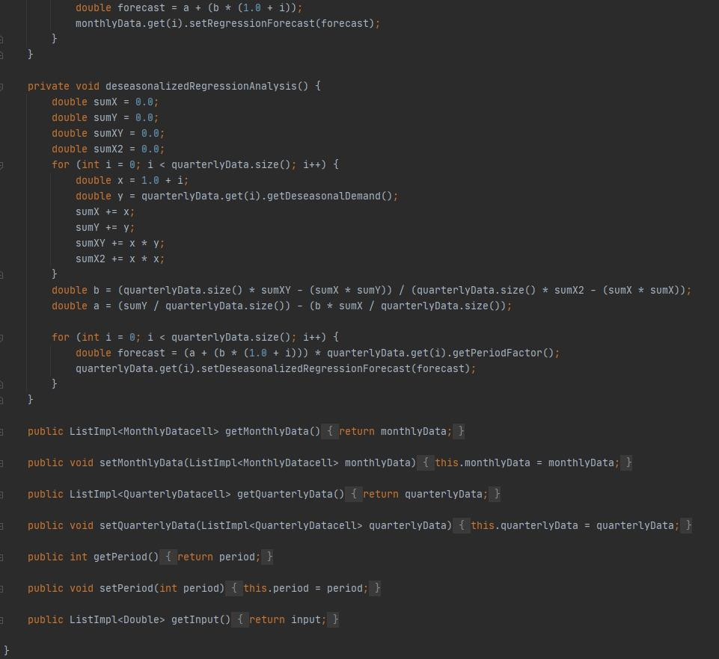

In our fillMonthlyData section, we accept every 3 months as a quarter and continue to calculate it accordingly. That is, as a result of a 3-month calculation, an estimate appears and this estimate is stored. By doing so, you will have access to short-term or long-term forecasts in a shorter time and flawlessly.

Since the forecast requested from us is 2 years old, it offers us the forecast by creating a total of 8 quarters

1.2

Main.java

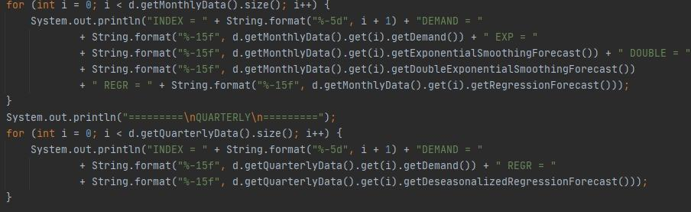

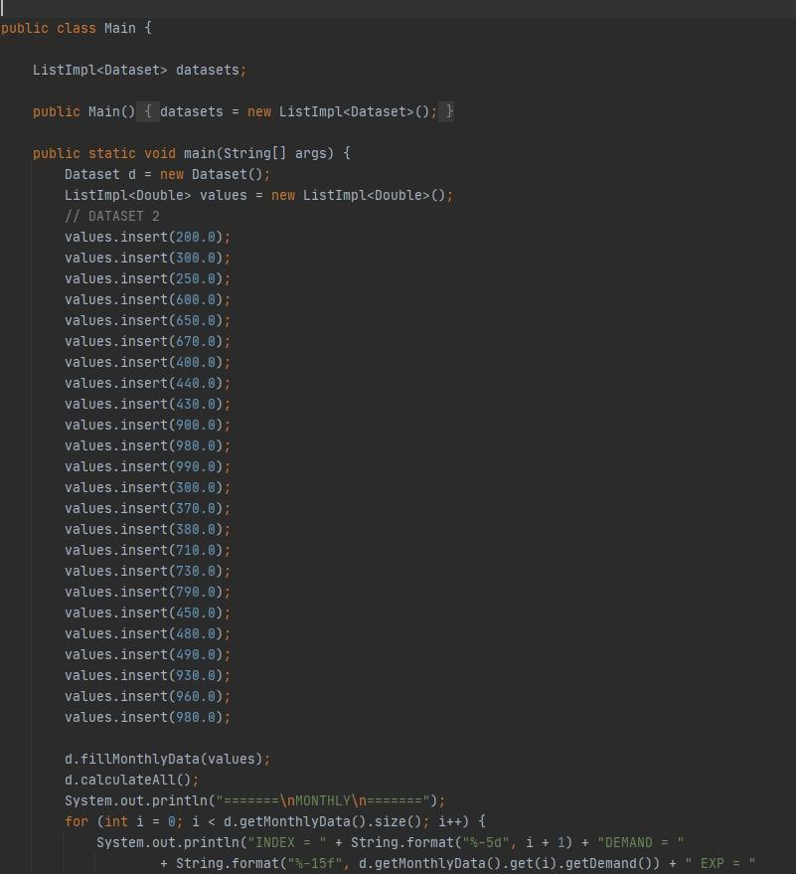

In this part, we used the datasets given to us. With it, the dataset.we have called the formulas of the analysis methods that we have written in java here. As a result, the calculation of the entered dataset data was made. You can see the output we received below. As you can see, the output we received matched the output from the excel files given to us from the industry department. Thus, the accuracy of the calculations was also confirmed.

Main.java output:

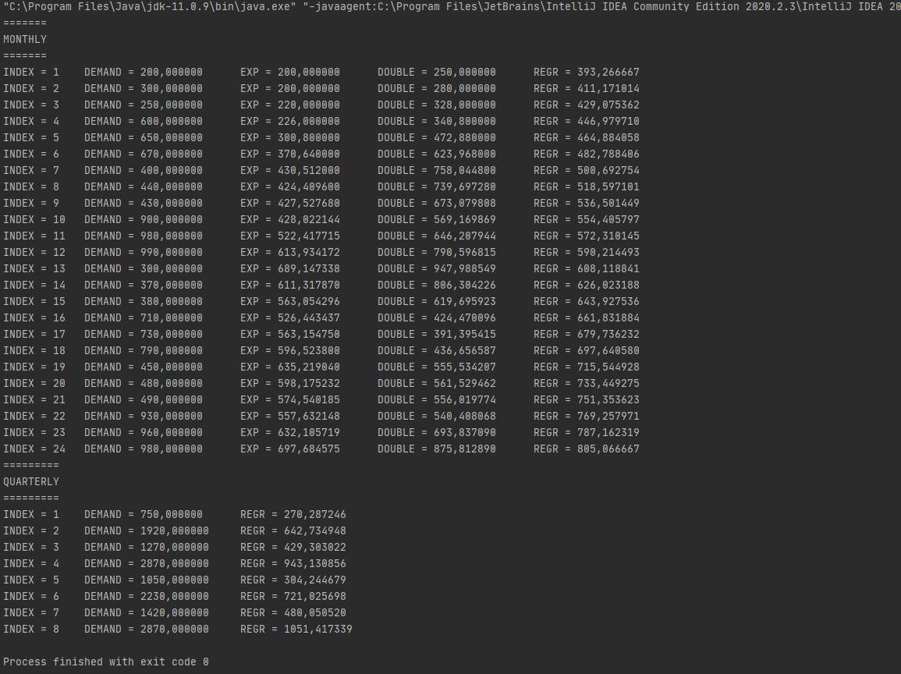

1.3

MonthlyDatacell.java

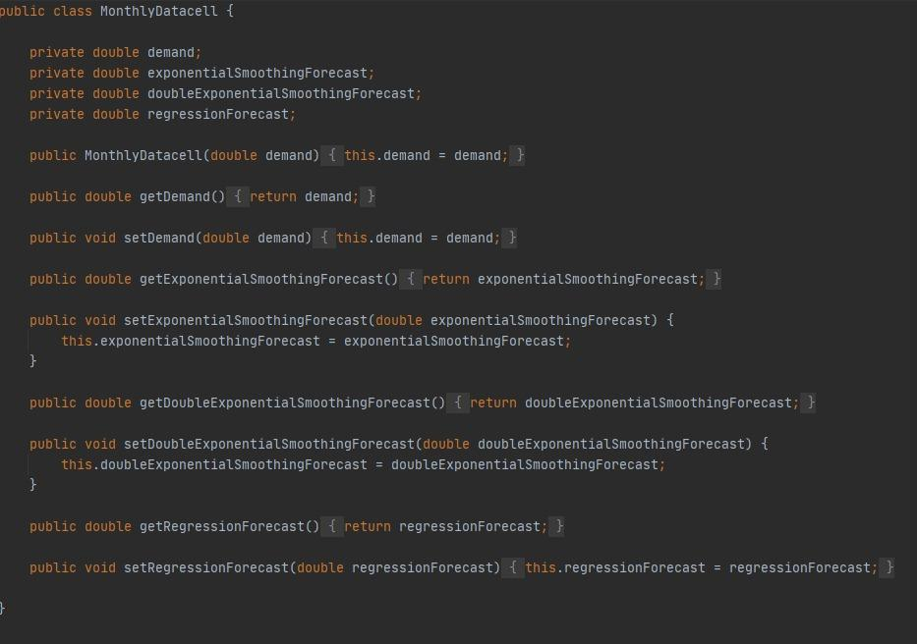

Here, we have made calculations for each month using the get and set methods in general, and to determine and keep the estimates formed as a result of these calculations. The reason we did this was to first convert the estimates that we set monthly, then to 3-month sets, and thus reach the 2-year forecast process.

1.4

QuarterlyDatacell.java

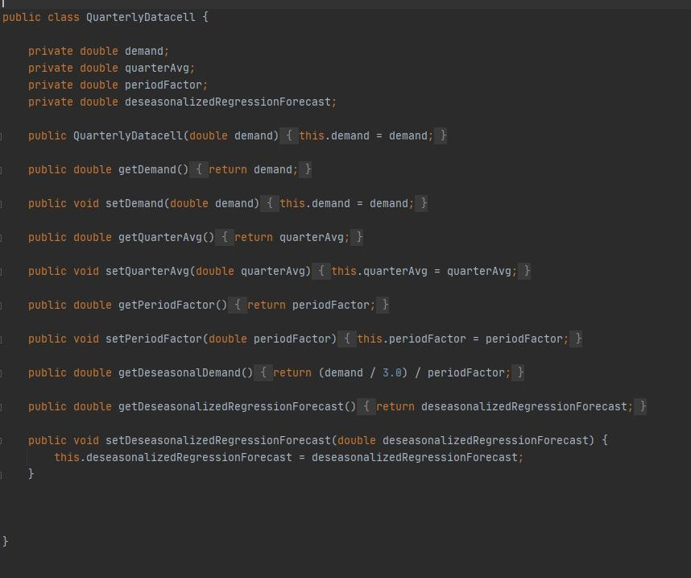

After the monthly estimates we have made, we have combined them into quarterly estimates. The forecast for each quarter consisted of 3 months. for a 2-year process, we need an estimate of 8 quarters. Again, we called our calculations using the get and set methods and made calculations of our data.

THE INTERFACE PART:

2.1

Main menu part

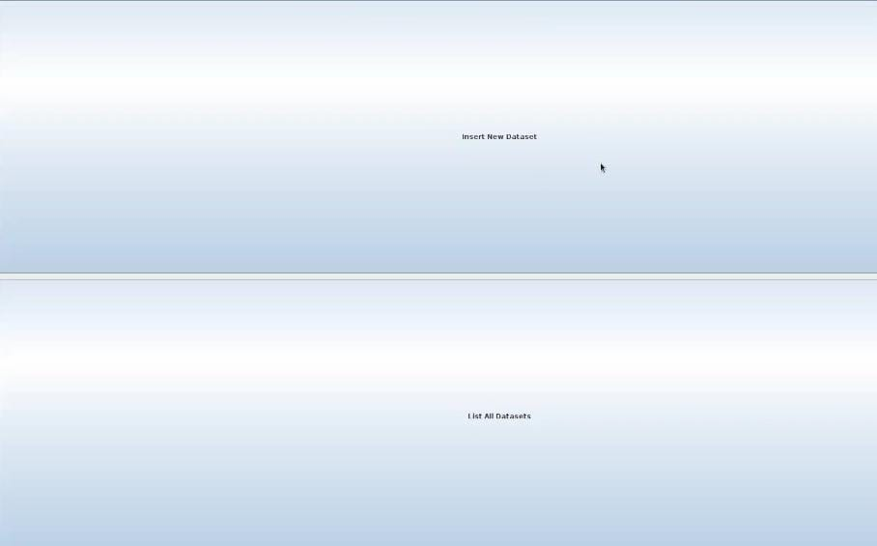

This is our main menu section. If we want to register a dataset, we press the

insert data button.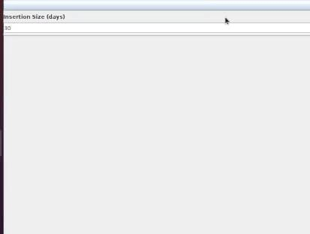

After pressing the Insert button, this tab opens, and here you are asked for information about how many days it will be saved with periods. The values are loaded when the desired period number of days is entered.These december december numbers cannot be entered because they are in the range of 0-720 values.In the List all dataset section, we can see the data we entered in the insert dataset.

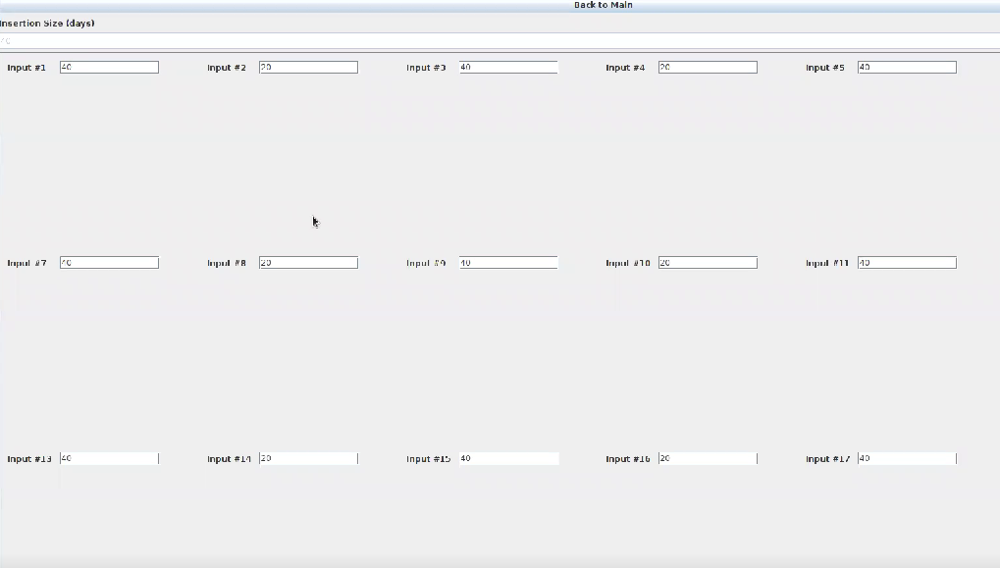

For example, when you want to enter a 40-day period, our input values are set to be 40 days.In this section, we write the datasets given to us in the input values. When we say list all, the datasets are saved in front of us.

2.2

Quarterly menu:

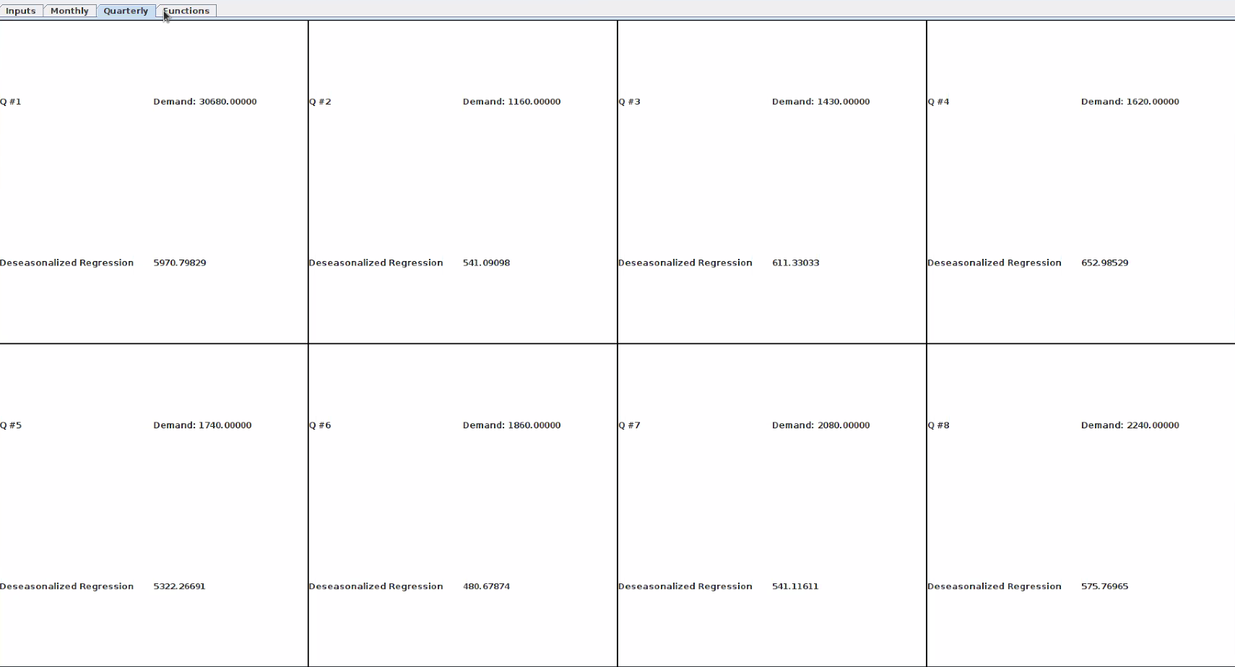

After entering our datasets, our quarterly calculations are made according to the received dataset data. We see it all clearly and clearly on the screen.

2.3

Monthly menu:

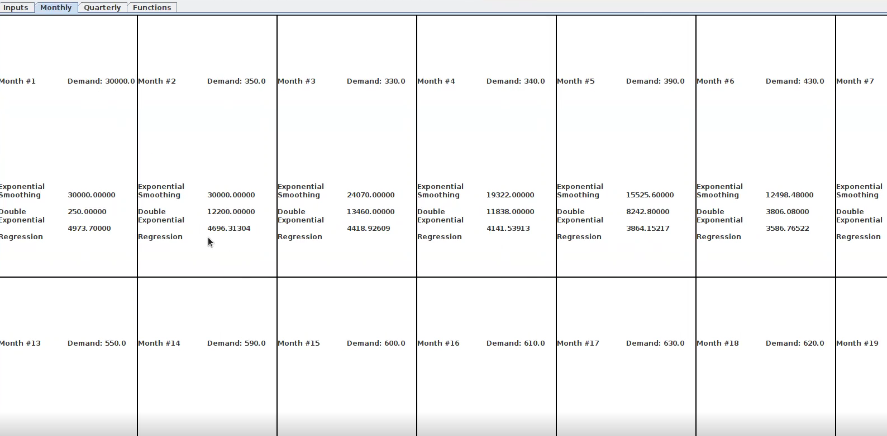

In this part, exponential analysis and regression analysis are performed thanks to the received datasets.This way we can see the forecast and data for that month.

2.4

Function menu:

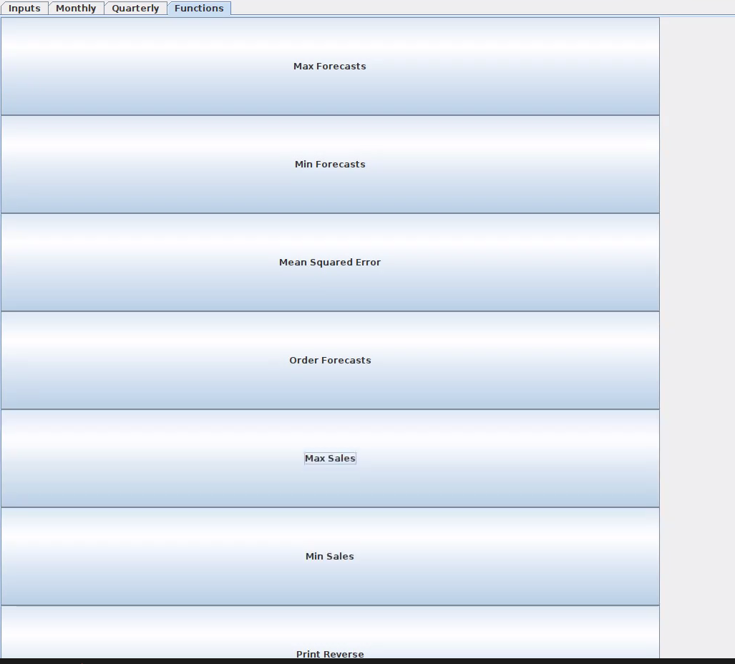

Finally, we move on to the most important part of our interface. In this section, we see the max and min forecasts values requested from us in the homework, the order forecast values,min sales,max sales,print reserve,mean squared error. In this section, we click on this button for the operation we want to do, and the data we want is presented to us thanks to the entered datasets.